How to deposit a newly accepted journal article or conference paper
This guide explains how to deposit a newly accepted journal article or conference paper in Symplectic Elements.

Before you start
Before you start, you will need the author accepted manuscript of your journal article or conference paper.
The author accepted manuscript – also known as an AAM, post-print, or accepted version – is the version of your paper that was accepted for publication following peer review, but has not yet been copy-edited or formatted by the publisher (unless it included formatting at the point of submission, eg. if submitted on a publisher-provided template).
Author accepted manuscript files are often Word format documents; a copy of this file saved as a PDF is preferred for deposit, where possible.
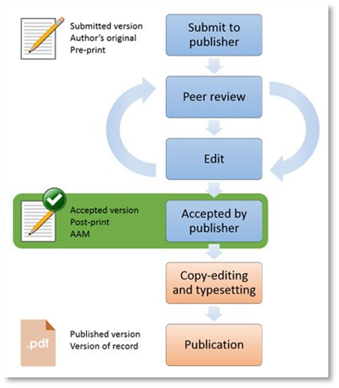

Depositing your journal article or conference paper
- Log in to Symplectic Elements https://publications.leeds.ac.uk using your University username and password.
- On your Homepage, go to your ‘My Actions’ tile (either carousel or list view) and find ‘Deposit accepted research outputs’. Click on ‘Deposit’.
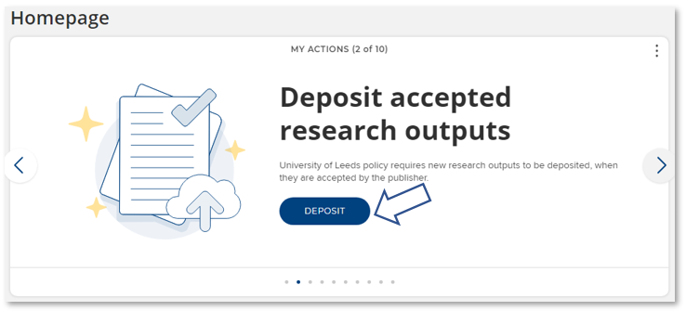
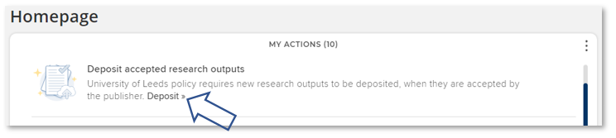
- An ‘On-acceptance deposit’ pop-up window will appear. Select either ‘Journal article’ or Conference paper’ from the two main buttons.
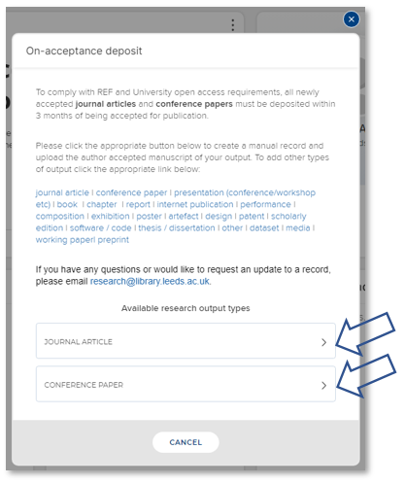
- You will be directed to a new ‘Let’s get started’ screen. Enter the Title or DOI for your output and click ‘Search’.
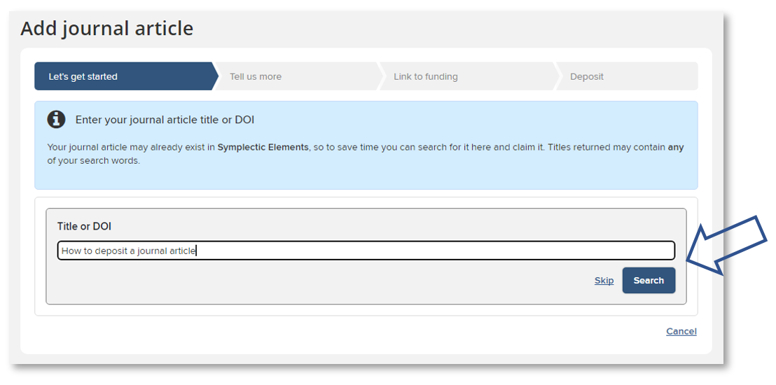
- Review any potential matches identified by the system:
- If the correct output is listed, click ‘Claim’ and skip ahead to step 8 below.
or
- If the correct output isn’t listed – or if you already know that the output does not exist in the system – then you can click on the ‘Skip’ button.
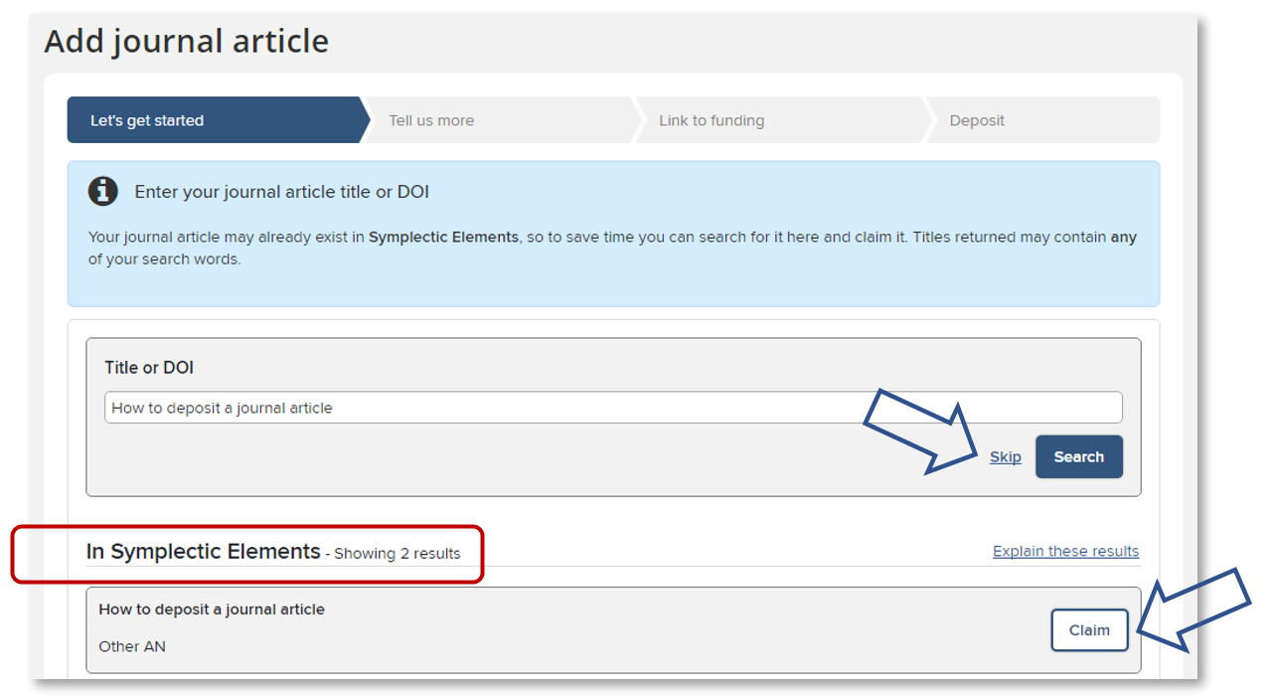

- You will be directed to a new ‘Tell us more’ screen where you can input details about your research output. Mandatory fields will be marked in the form with an asterisk *.
Detailed guidance on how to fill out the fields can be found by hovering over the question marks in the form generated for your output type, or by scrolling down to the ‘Adding details about your research output’ section of the below instructions.
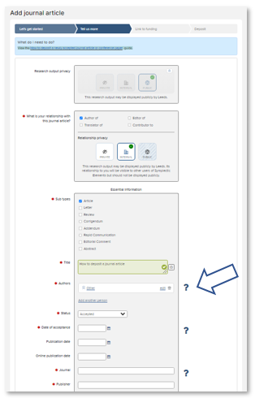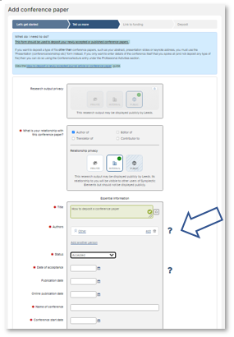
- Once you have filled out the relevant fields, click the ‘Save’ button near the bottom of the screen.
- You will be directed to a new ‘Link to funding’ screen. Grants you are associated with should be listed on this screen:
- If the research was externally funded and the grant(s) can be seen in the list, tick the appropriate grant(s), click on ‘Link selected’ then ‘Done’.
or
- If the research was externally funded but the grant(s) cannot be seen in the list, click on ‘Grant not listed’. (You can also click this option if you do not currently have the funding information to hand and intend to add this information later.)
or
- If the research was not externally funded, click on ‘Not externally funded’.
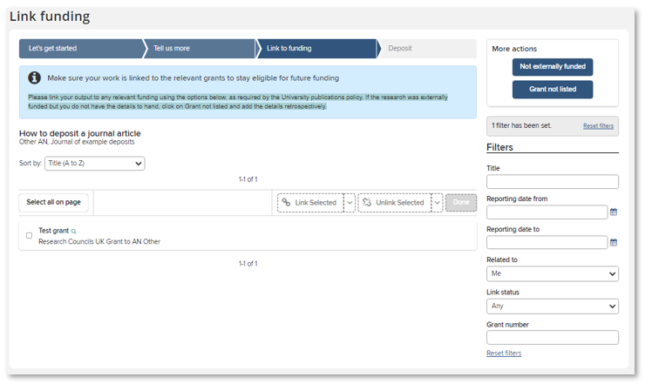
NB: Additional guidance on how to link a research output to funding can be found in Symplectic Elements via the ‘Help’ menu.
- You will be directed to a new ‘Deposit’ screen, where you can upload your author accepted manuscript file. Click the ‘Choose file’ button and navigate to your file. Select ‘Author accepted manuscript’ from the file version drop-down menu and click ‘Use this file’.
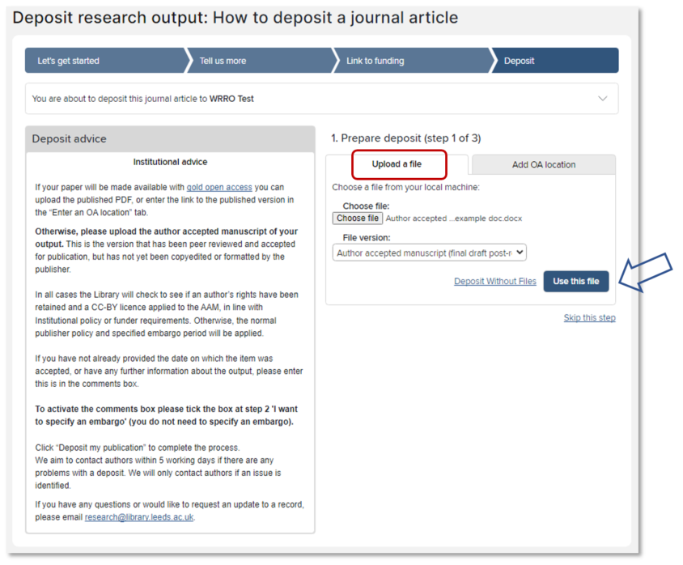
- The screen will update with the file you have selected. If you would now like to add a comment or message for the Library team, click the ‘I would like to specify an embargo’ box to activate the ‘Comment’ free-text field. (Please note: You do not need to specify an embargo period.)
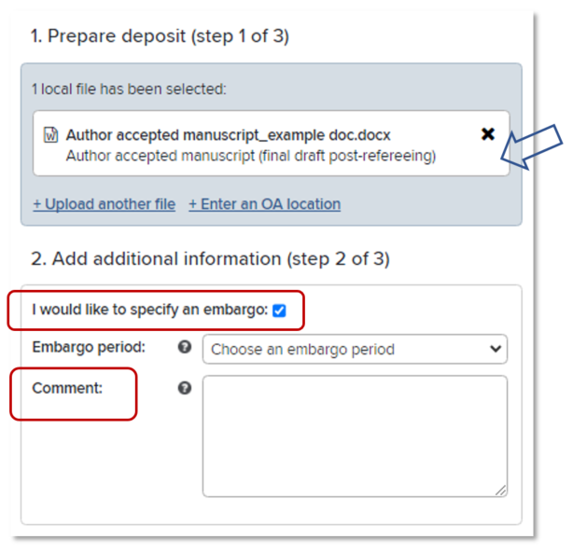
- Complete the process by clicking the ‘Deposit’ button. (Please note: If you leave the record without completing the deposit process, it will appear on your Homepage under ‘My Actions’ as an item requiring attention.)
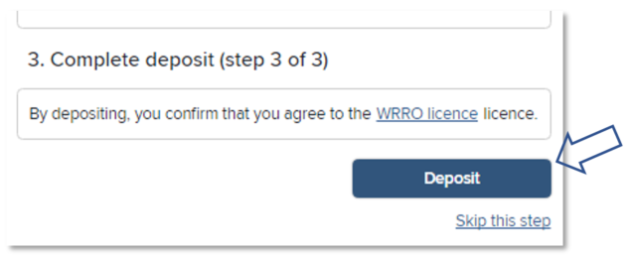
- Once you have deposited your journal article or conference paper you will be directed to a ‘Thank you’ screen where you can see the status of your deposit and any other actions that you may be prompted to take.

What happens next
Once deposited, the Library will check to see if an author’s rights have been retained and a CC-BY licence has been applied to the author accepted manuscript (AAM) file, in line with Institutional policy or funder requirements. Otherwise, the normal publisher policy and specified embargo period will be applied. The file will be made publicly available from the institutional repository, White Rose Research Online (WRRO), as soon as copyright and licensing permits. You will only be contacted if there is a problem.
If you have any questions about your deposit, please email research@library.leeds.ac.uk.

Adding details about your journal article or conference paper

Journal article form
Please input/edit the following mandatory details in the template form that is generated for your journal article. These fields will be marked in the form with an asterisk *.
- What is your relationship with this journal article?: Select from the listed options (eg. Author of, Translator of, Editor of, or Contributor to). You will also be prompted to select your preferred ‘Relationship privacy’ level (Private, Internal, or Public). Additional guidance on privacy level settings and options in Symplectic Elements can be found via the Information about privacy settings link in the main ‘Help’ menu.
- Sub types: Select from the listed journal article subtype options.
- Title: Please enter manually if not already present in the form.
- Authors: Select ‘Add a person’ to add (co) authors to the Authors list. New fields will open that allow you to add the last name and first name of the new person. The author type (eg. corresponding author, first author, last author) can also be specified here via the drop-down menu, as can creative and contributor roles (see https://credit.niso.org/ for further information). When you are happy with the new entry, select ‘+ Add’. The author order can be changed by using the arrows next to each entry, or using the ‘drag and drop’ functionality.
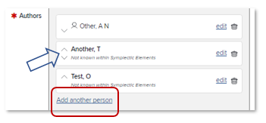
- Status: Select from the listed publication status options (eg. Accepted, Published online, Published, etc). NB: If you are depositing on acceptance, please select ‘Accepted’.
- Dates: Please enter manually or select from the drop-down calendar the date on which the output was accepted for publication. If the output has already been published, please add that date to the corresponding field as well.
- Journal: Once you start to type you may be able to select the journal from a drop-down menu. Otherwise, please manually enter the full title of the journal.
- Publisher: Please enter manually or confirm any auto-filled details.
- Rights retained and an open licence (e.g. CC-BY) applied to the author accepted manuscript: Please select ‘Yes’ or ‘No’ as appropriate to indicate whether for the purposes of open access you have retained your rights to the author accepted manuscript (AAM) version of this output by applying an open licence (CC-BY, CC-BY-ND, or OGL). Please use the ‘Comment’ field on the ‘Deposit’ screen if you would like to provide further details (see step 10 above). Further information and guidance on retaining your rights can be found via the Library webpage on Rights retention.
- Data access statement included: Please select ‘Yes’ or ‘No’ as appropriate to indicate whether you have included a data access statement on the author accepted manuscript (AAM) or published version of this output in line with funder and institutional requirements. Please use the ‘Comment’ field on the ‘Deposit’ screen if you would like to provide further details (see step 10 above).

You may also choose to provide the following optional details about your journal article if you already have the relevant information. Otherwise, these fields may be left blank:
- DOI: The digital object identifier (DOI) for the published version of this journal article.
- Associated dataset [link]: The DOI or URL for a dataset associated with this journal article.
- Additional information section: If you would like further information, such as the abstract or keywords, to be publicly visible in the University’s Repository (White Rose Research Online) prior to publication, you may expand the ‘Additional Information’ section to access further fields. Otherwise, these fields will be completed by the Library once the item is published.

Conference paper form
Please input/edit the following mandatory details in the template form that is generated for your conference paper. These fields will be marked in the form with an asterisk *.
- What is your relationship with this conference paper?: Select from the listed options (eg. Author of, Translator of, Editor of, or Contributor to). You will also be prompted to select your preferred ‘Relationship privacy’ level (Private, Internal, or Public). Additional guidance on privacy level settings and options in Symplectic Elements can be found via the Information about privacy settings link in the main ‘Help’ menu.
- Title: Please enter manually if not already present in the form.
- Authors: Select ‘Add a person’ to add (co) authors to the Authors list. New fields will open that allow you to add the last name and first name of the new person. The author type (eg. corresponding author, first author, last author) can also be specified here via the drop-down menu, as can creative and contributor roles (see https://credit.niso.org/ for further information). When you are happy with the new entry, select ‘+ Add’. The author order can be changed by using the arrows next to each entry, or using the ‘drag and drop’ functionality.
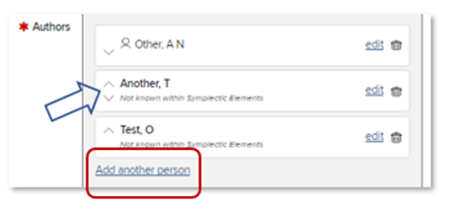
- Status: Select from the listed publication status options (eg. Accepted, Published online, Published, etc). NB: If you are depositing on acceptance, please select ‘Accepted’.
- Dates: Please enter manually or select from the drop-down calendar the date on which the output was accepted for publication. If the output has already been published, please add that date to the corresponding field as well.
- Name of conference: Please enter manually.
- Conference start date: Please enter manually or select from the drop-down calendar.
- Published proceedings: Once you start to type you may be able to select the title from a drop-down menu. Otherwise, please manually enter the full title of the published proceedings. If you do not yet know where it will be published, please enter “To be confirmed”.
- Publisher: Please enter manually or confirm any auto-filled details. If you do not yet know the publisher, please enter “To be confirmed”.
- Rights retained and an open licence (e.g. CC-BY) applied to the author accepted manuscript: Please select ‘Yes’ or ‘No’ as appropriate to indicate whether for the purposes of open access you have retained your rights to the author accepted manuscript (AAM) version of this output by applying an open licence (CC-BY, CC-BY-ND, or OGL). Please use the ‘Comment’ field on the ‘Deposit’ screen if you would like to provide further details (see step 10 above). Further information and guidance on retaining your rights can be found via the Library webpage on Rights retention.
- Data access statement included: Please select ‘Yes’ or ‘No’ as appropriate to indicate whether you have included a data access statement on the author accepted manuscript (AAM) or published version of this output in line with funder and institutional requirements. Please use the ‘Comment’ field on the ‘Deposit’ screen if you would like to provide further details (see step 10 above).

You may also choose to provide the following optional details about your conference paper if you already have the relevant information. Otherwise, these fields may be left blank:
- Conference finish date: Please enter manually or select from the drop-down calendar.
- Conference place: Please manually enter the location that the conference was held.
- DOI: The digital object identifier (DOI) for the published version of this conference paper.
- Associated dataset [link]: The DOI or URL for a dataset associated with this conference paper.
Additional information section: If you would like further information, such as the abstract or keywords, to be publicly visible in the University’s Repository (White Rose Research Online) prior to publication, you may expand the ‘Additional Information’ section to access further fields. Otherwise, these fields will be completed by the Library once the item is published.

Further information
Help and user guides for Symplectic Elements can be found via the ‘Help’ menu at the top right of the Home page:
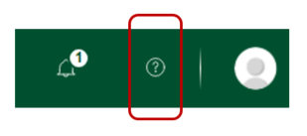
Further information can also be found via the IT Service Desk or the Library’s Open Access pages.
For general Symplectic Elements queries, please contact the IT Service Desk or telephone: +44 (0)113 343 3333.

