How to deposit a preprint
This guide explains how to deposit a new preprint output in Symplectic Elements.
Please note: the preprint template should only be used for outputs that are not under review with a journal. For outputs that have been submitted to or accepted by a journal, please instead use the journal article template.

Depositing a preprint
- Log in to Symplectic Elements https://publications.leeds.ac.uk using your IT username and password.
- On your Homepage, scroll down to your ‘Research outputs’ tile and click the plus sign (+) ‘Add New’.
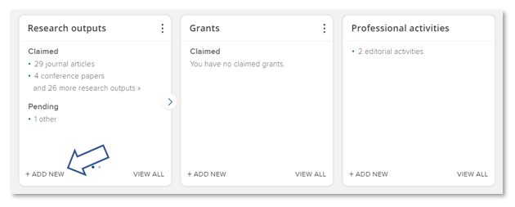
- A new ‘Add a new research output’ window will open. Choose ‘Preprint’ from the options listed.
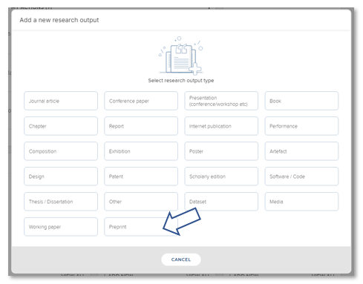
- You will be directed to a new ‘Let’s get started’ screen. Enter the Title or DOI for your preprint and click ‘Search’.
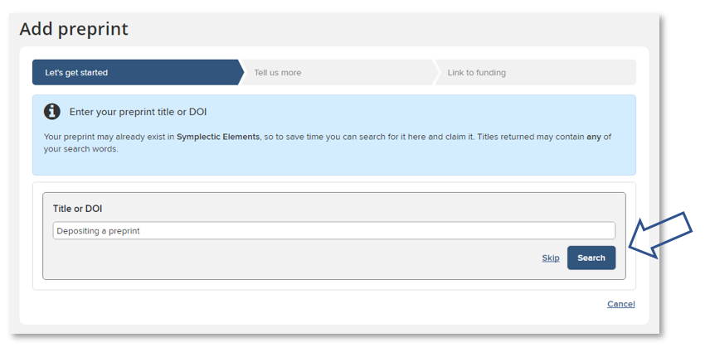
- Review any potential matches identified by the system:
- If the correct preprint is listed, click the ‘Claim’ button and skip ahead to step 8 below.
or
- If the correct preprint is not listed – or if you already know that the preprint does not exist in the system – then you can click on the ‘Skip’ button.
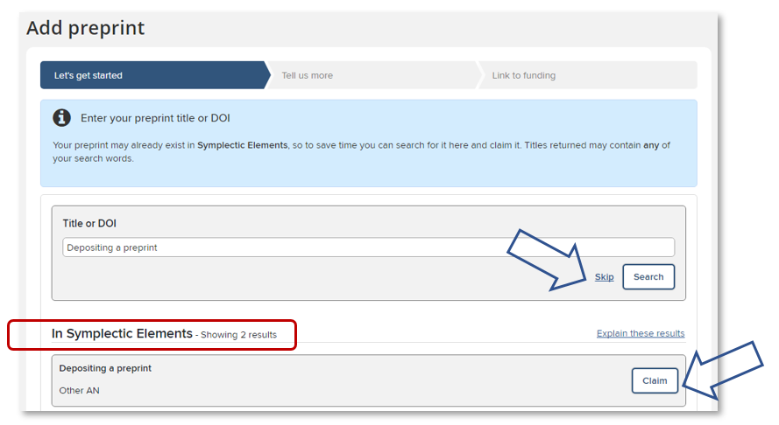
- You will be directed to a new ‘Tell us more’ screen where you can begin to populate the preprint form. Mandatory fields are marked in the form with a red asterisk *.
- You will be prompted to select your preferred ‘Relationship privacy’ level (Private, Internal, or Public). Additional guidance on privacy level settings and options in Symplectic Elements can be found via the Information about privacy settings link in the main ‘Help’ menu.
- Add as much additional information as you can, including the preprint server the output is posted on (eg. Arxiv, BioRxiv, SSRN, etc.) and the DOI or Publisher URL that leads to the output on the preprint server (please do not add a link to any other version).
- The ‘Publication date’ is the date the preprint appeared on a preprint server – this field can also be left blank.
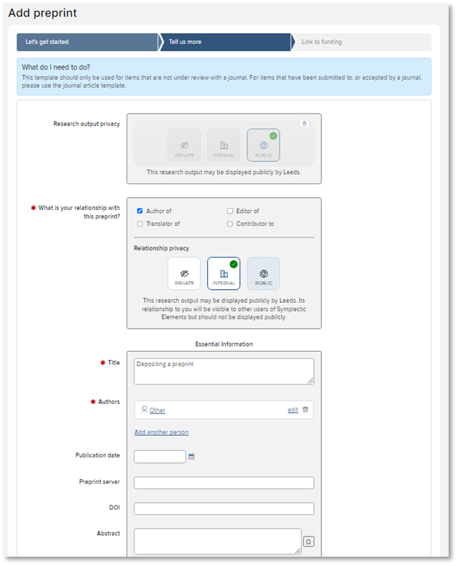
- Once you have filled out the relevant fields, click the ‘Save’ button near the bottom of the screen.
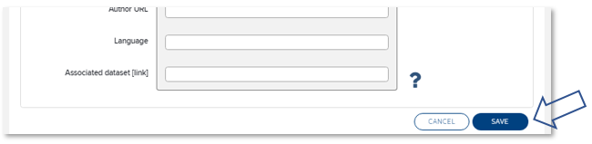
- You will be directed to a new ‘Link to funding’ screen. Grants you are associated with should be filtered for by default and listed on this screen:
  - If the research was externally funded and the grant(s) can be seen in the list, tick the appropriate grant(s), click on ‘Link selected’, then ‘Done’.
or
  - If the research was externally funded but the grant(s) cannot be found in the list, click on ‘Grant not listed’. (You can also click this option if you do not currently have the funding information to hand and intend to add this information later.)
or
  - If the research was not externally funded, click on ‘Not externally funded’.
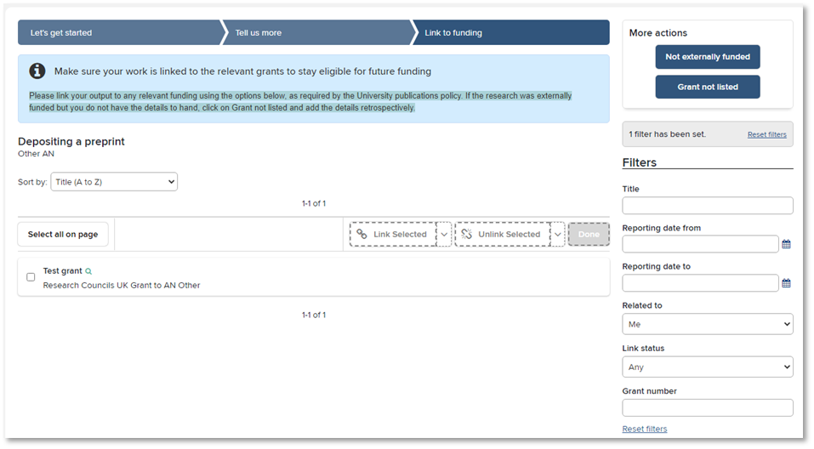
- You will be taken to a new ‘Thank you’ screen, where you can now deposit the preprint by clicking on the ‘Deposit to White Rose Research Online’ button.
- You will be taken to a new ‘Deposit’ screen:
  - If you would like to add a preprint file, you can upload it here. Click ‘Choose file’ and navigate to your file. Select ‘Preprint (pre-submission)’ from the ‘File version’ drop-down menu, then click the ‘Use this file’ button. (Note: a PDF version of the file is preferred, where possible.)
or
  - If you do not wish to add a preprint file, you can click the ‘Deposit without files’ link.
or
  - You can instead choose to enter a link to a publicly available preprint version. Select the ‘Add OA location’ tab, enter the URL, select ‘Preprint (pre-submission)’ as the version from the drop-down menu, then click the ‘Save location’ button.
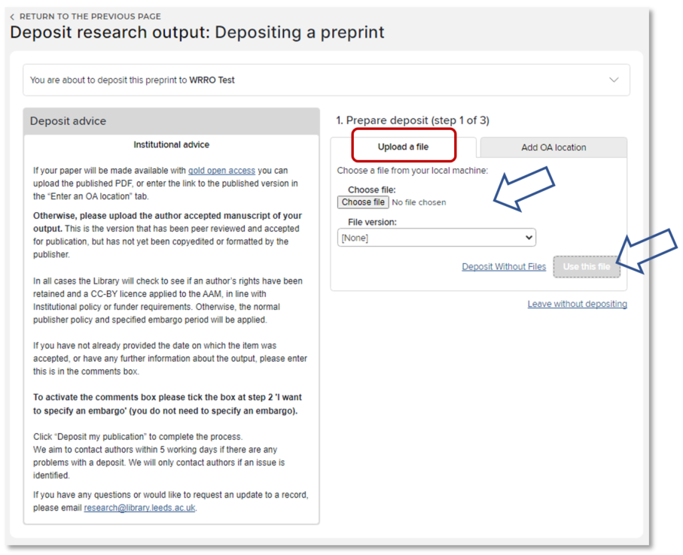
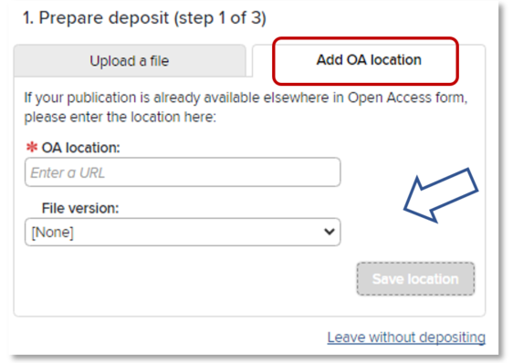

- The screen will update with confirmation of any file or link that you have provided. If you would now like to add a comment or message for the Library team, click the ‘I would like to specify an embargo’ box to activate the ‘Comment’ free-text field. (Please note: you do not need to specify an embargo period.)
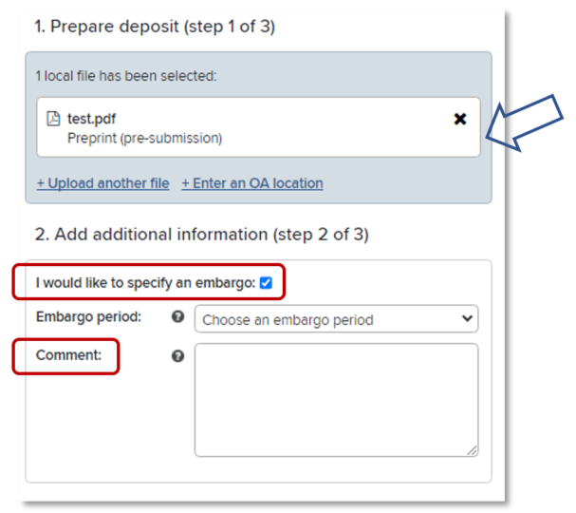
- Complete the process by clicking the ‘Deposit’ button
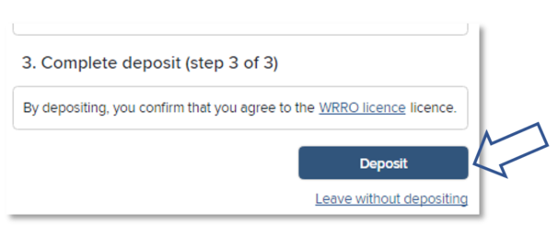

What happens next
Once the item is deposited, the Library will check the item and will contact you if there are any queries.
Any preprints that are made publicly available via the institutional repository, White Rose Research Online (WRRO), will have a clear banner confirming the item is a preprint and as such it may not have undergone formal peer review.
If you have any questions about your deposit, please contact research@library.leeds.ac.uk

Further information
Help and user guides for Symplectic Elements can be found via the ‘Help’ menu at the top right of the Home page:
Further information can also be found via the IT Service Desk or the Library’s Open Access pages.
For general Symplectic Elements queries, please contact the IT Service Desk or telephone: +44 (0)113 343 3333.

