

Visual Story
  - For visitors to the Galleries



Contents
Visual Story 1
Introduction to the Gallery 3
Sensory information 5
Sensory map 8
Finding the Gallery 9
Map of Parkinson Building 13
When you arrive 14
Rules in the Gallery 16
Things you can do in the Gallery 18
What will you see? 19
What can you borrow? 21
Seating 24
Eating and drinking 26
Finding the bathrooms 28
Accessible bathrooms 31
If you hear the fire alarm 33
Shop 34
Leaving the Gallery 35
Contact us 36

Introduction to the Gallery
The Stanley & Audrey Burton Gallery is an art gallery.  It is part of the University of Leeds. | 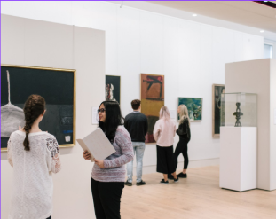
Entry to the Gallery is free.  Anyone can visit. It is open to the public.  You do not need to book a ticket. Just walk in. | 
It is open:  Tuesday  Wednesday  Thursday  Friday  Saturday | 
It is closed:  Sunday  Monday  and some holidays.  You can check these dates online, or call us. | 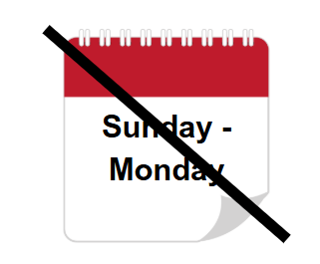
It is open from 10.00am to 5.00pm. | 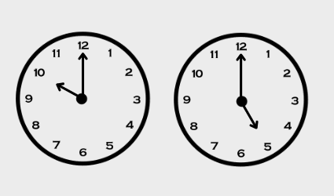
You can find more information  on our website  on our social media  by telephone  by email  by asking a member of staff | 

Sensory information
The Gallery is usually quiet.  There might be groups or families visiting.  There are fewer visitors at the start and end of the day. | 
Sometimes there are events in the Gallery.  This can be busy with big crowds and noise.  You can call us on 0113 343 2778 to find out how busy the gallery may be. | 
Sometimes there will be sound in the Gallery.  This could be music or sound from a video.  You can borrow ear defenders, or avoid areas marked on the sensory map. | 
The Gallery is brightly lit.  The walls are white, and the lights are artificial. | 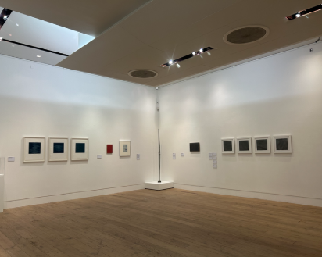
There may be screens with bright or moving images.  There will be signs if there any flashing lights. | 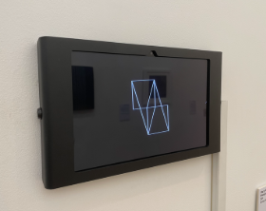
There is a hearing loop in the Gallery.  Switch to the ‘T’ position.  We can provide Wi-Fi access. | 
The Parkinson Court is used for University events.  This can be busy with big crowds and noise. | 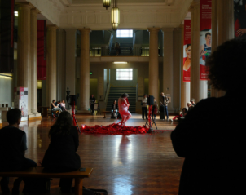
In the entrance to the Parkinson Building, there is a piano that people can play.  This can be noisy as you walk through to the Gallery. | 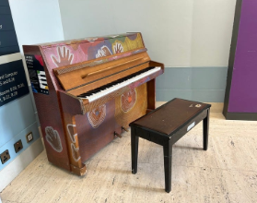
You can borrow sensory items to use in the Gallery.  Please use the space how it is comfortable for you. | 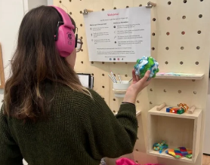

Sensory map
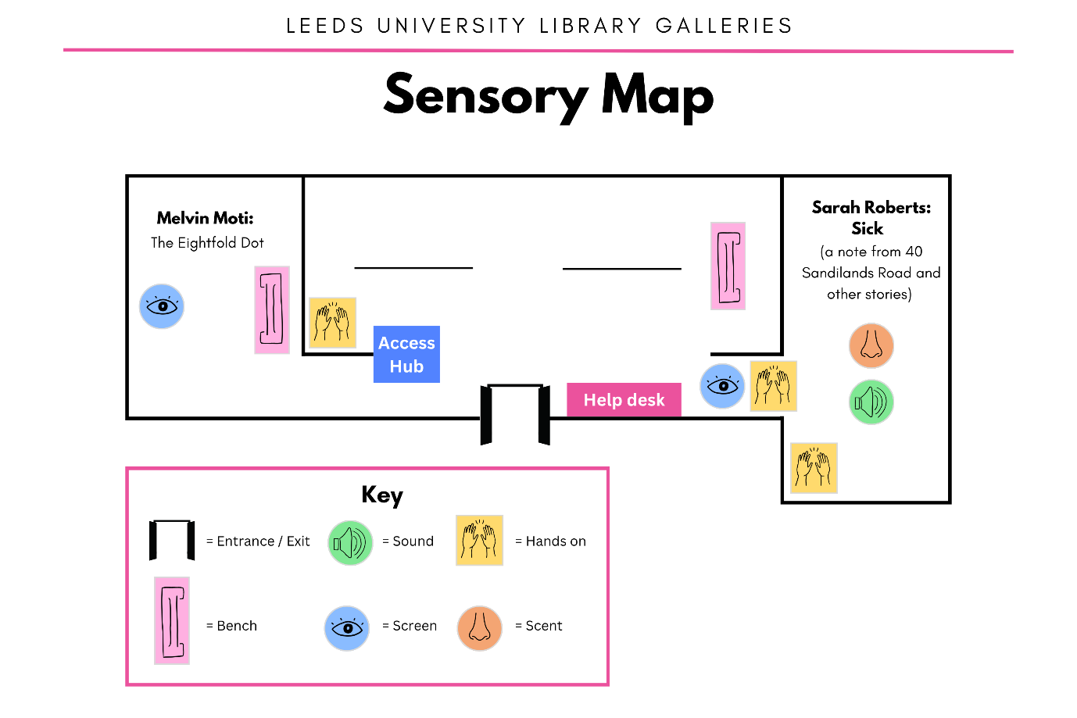
This may change based on what’s on.
You can borrow an up-to-date copy in the Gallery during your visit.

Finding the Gallery
The Stanley and Audrey Burton Gallery is in the Parkinson Building, University of Leeds.  This is a large, grey building with a big clock tower. | 
You can get here on local transport or by car.  From the train station, it is a 30 minute walk. Or, ask for “Parkinson Steps’ on bus services 22, 23, 24, 25, 26, 27, 28, or 56. | 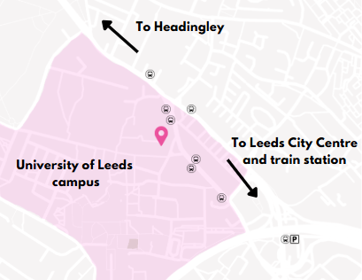
There is no public parking on campus. We can book nearby parking for blue badge holders.  Please email or call before your visit to arrange. | 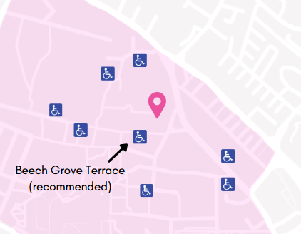
The main entrance is up 22 steps, or the exterior accessible lift. | 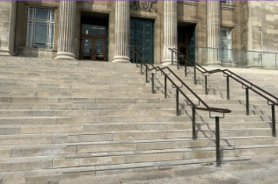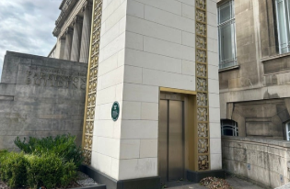
Through the foyer, you will enter the Parkinson Court.  This large area is open to the public. | 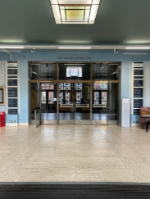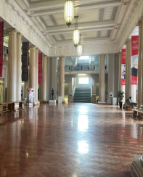
Other parts of the building are not open to the public. For example, the Brotherton Library.  Staff and students can enter these areas with a pass. | 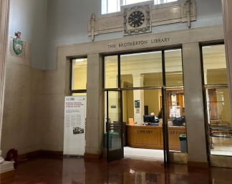
You can find the Gallery entrance underneath the pink banners in Parkinson Court. | 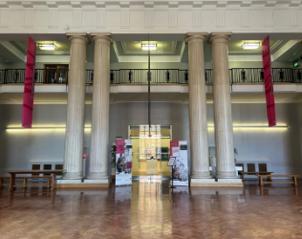
Follow the signs to find the glass doors. | 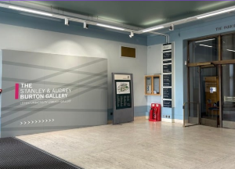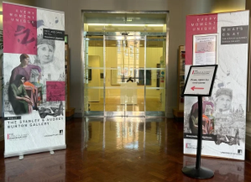
You can ask any member of staff for directions.  Find them at the Help Desk or Brotherton Library. | 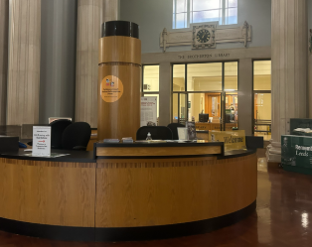

Map of Parkinson Building
Copies of this map are available in the Gallery.
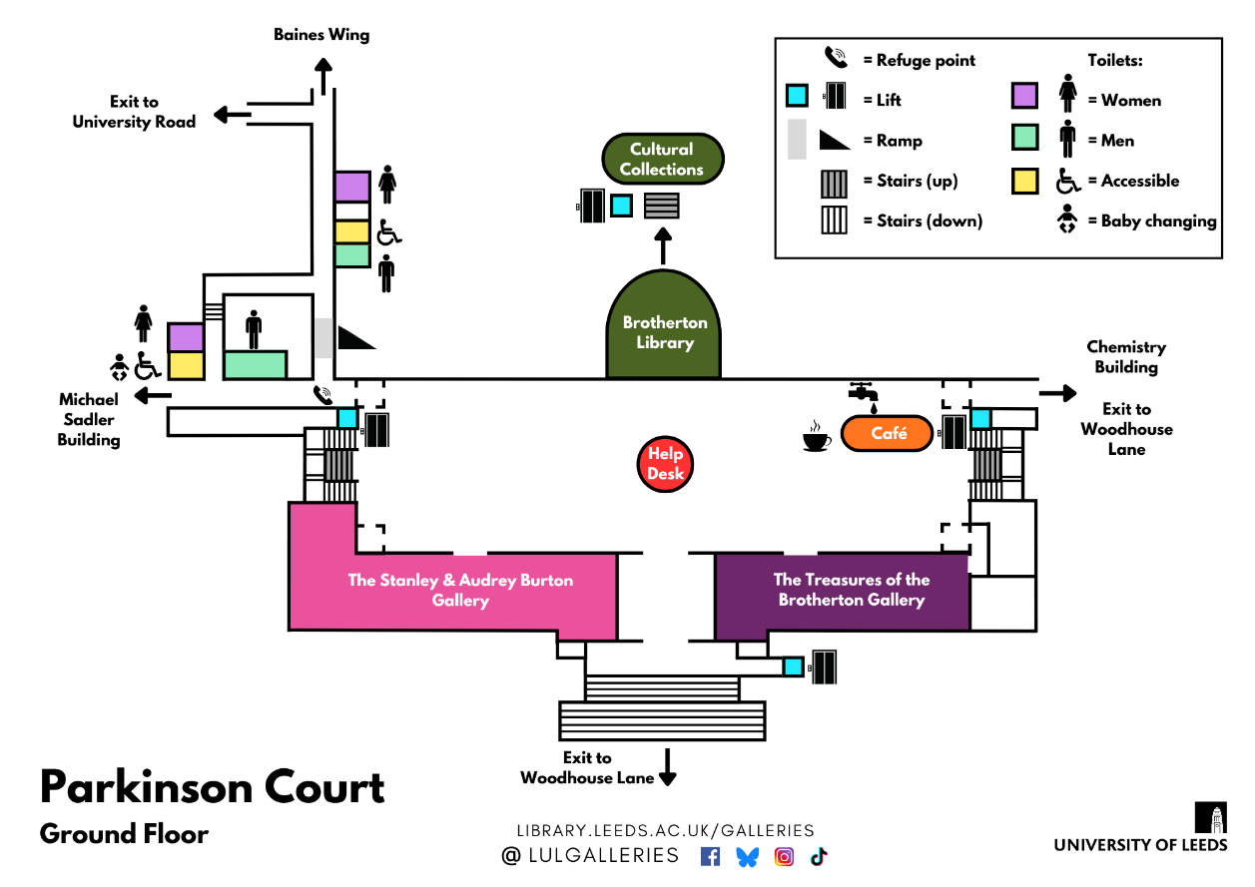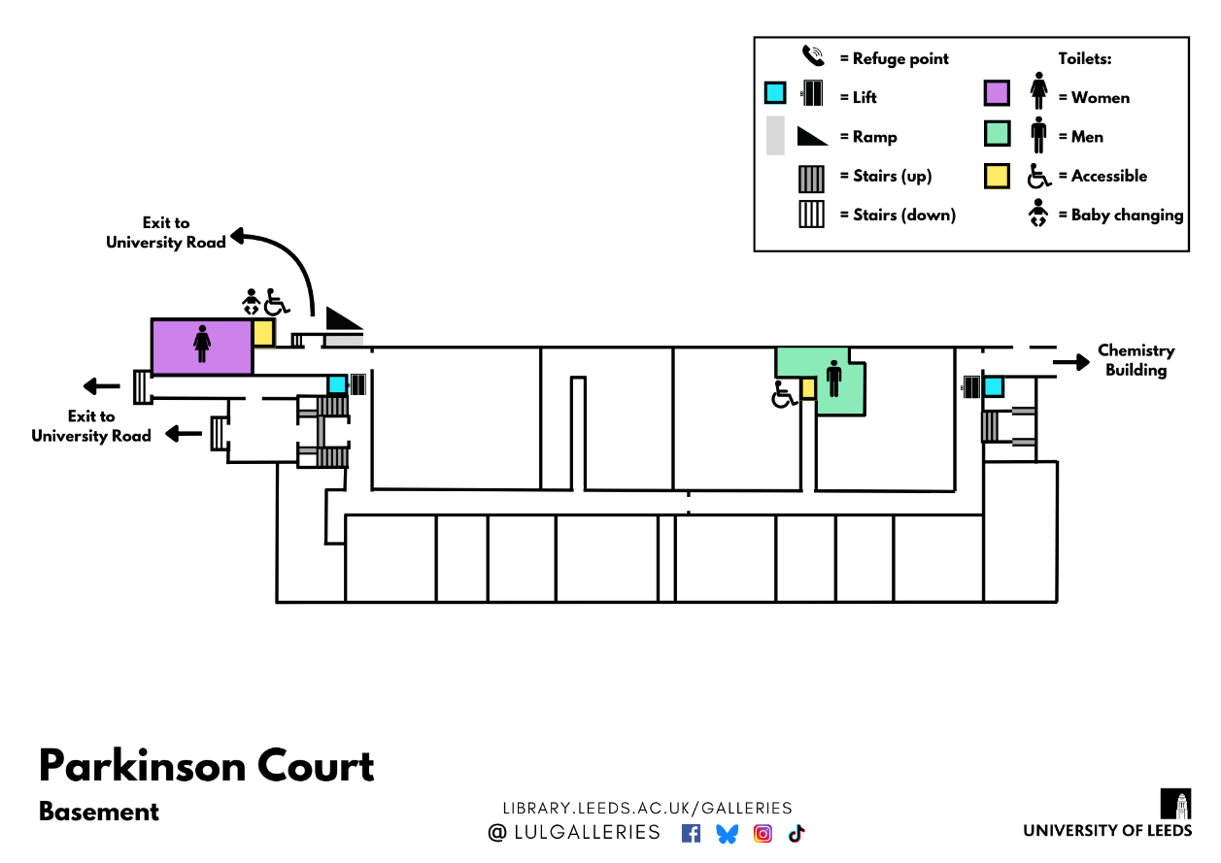

When you arrive
The glass doors will slide open.  A member of staff will greet you and say hello.  They don’t wear a uniform, but do wear a green lanyard. | 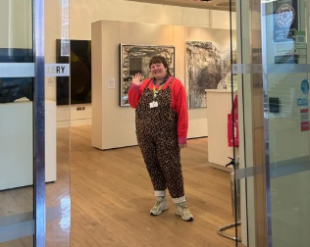
Staff will be sitting behind the desk. Sometimes they will walk around.  You can ask them for help, information or directions. | 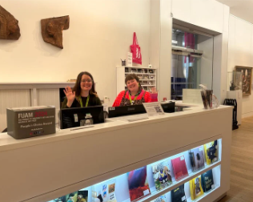
They might ask you to complete a survey.  You can say yes or no.  You can tell them your answers, or fill out the survey yourself. | 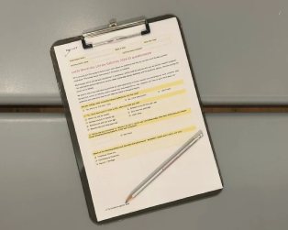
It is okay if you do not want to chat.  You can wear a red ‘Please leave me alone’ wristband and staff will respect your privacy. | 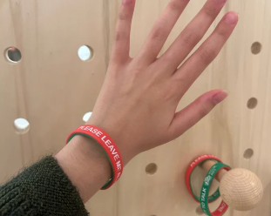
There is no cloakroom or lockers.  You will carry your coats and bags with you whilst exploring the gallery. | 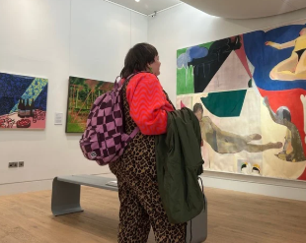
Staff will ask you to leave your food or drink at the desk.  This is to protect the artworks. You can collect it at the end of your visit. | 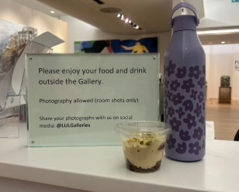

Rules in the Gallery
You cannot touch the artworks. | 
You cannot eat in the Gallery. | 
You cannot drink in the Gallery. | 
You cannot take photos with flash. | 
These rules help to protect the artwork from any damage.  If you are not sure what you can and cannot touch, please ask a member of staff. | 

Things you can do in the Gallery
You can look at the artworks.
You can sit and rest on a bench, stool, or beanbag.
You can read the text panels.
You can take photos without flash.
You can touch some things.
For example, write a comment or open drawers.
You can draw or write with pencils.
You can talk to the staff and ask questions.
You can relax and enjoy the less busy atmosphere.
You can buy a souvenir from the gift shop.
You can chat about what you like and don’t like.
You can take leaflets from the desk.
You can stay for as long or as little time as you like.

What will you see?
The Stanley and Audrey Burton Gallery is a small gallery.  There are 3 rooms. | 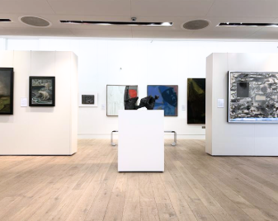
The main room shows artworks from the University Art Collection.  The University looks after thousands of artworks. Around 1 out of 10 are on display. | 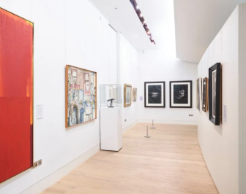
Two more rooms are for temporary exhibitions.  The displays change often. You might see something different every time you visit. | 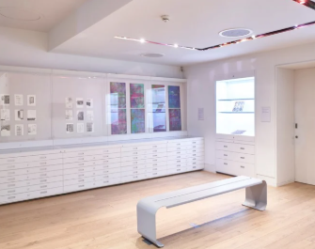
You will see different types of art, from the 17th century to today.  This might include drawings, paintings, sculptures, films and installations. | 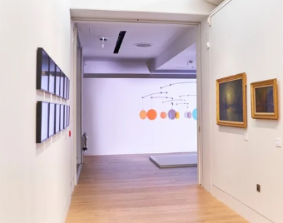
Every artwork has a label.  It tells you the title, who made it, and when. Some describe what it shows, or how it was made. | 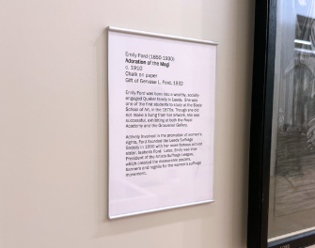
You can pick out the things that interest you, in any order.  You can look at things as long or as little as you like. | 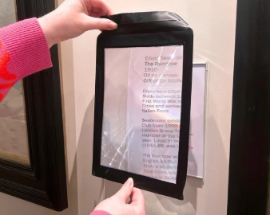

What can you borrow?
There are items that are free to borrow to help enjoy your visit.  You can take anything off the ACCESSories Hub and use it in the Gallery. | 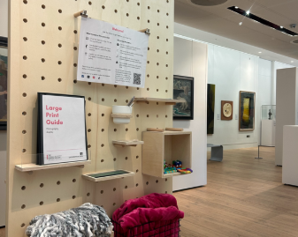
You can borrow:
- Blankets
- Coloured plastic overlays
- Cushions
- Ear defenders
- Fidget toys
- Large print guides
- Magnifying glasses
- Magnifying sheets
- Maps of the building
- Masks
- Mood bands
- Pencils with grips
- Ramble tag
- Reading windows
- Sensory maps
- Slow-looking prompts
- Translations (Arabic and Chinese)
- Visual story
- Weighted lap pad
- Weighted shoulder wrap
- Yoga mats

Please return items here before you leave.  We will clean them for another person to use. | 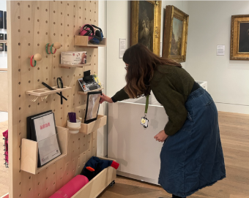
You can use items to help you:  Get info | 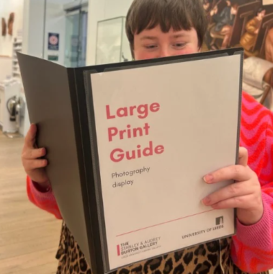
Get comfortable | 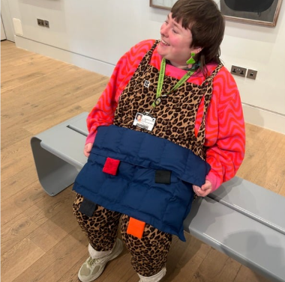
Get exploring | 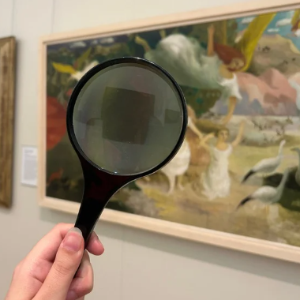
Get creative | 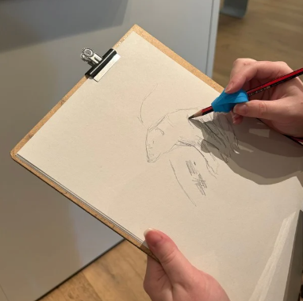

Seating
In the Gallery, you can sit and rest on a bench, stool, or beanbag.  You can find metal benches around the Gallery. | 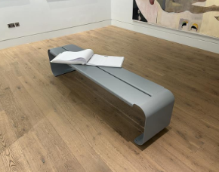
There are two sets of stools.  You can take a stool and sit anywhere in the Gallery. | 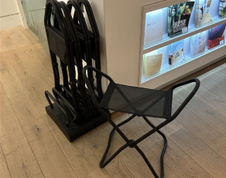
You can ask a member of staff for a chair with a back.  We can help you move the chair. You can sit anywhere in the Gallery. | 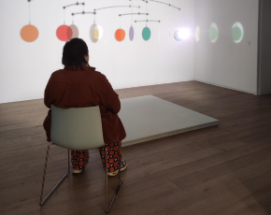
You can ask a member of staff for a beanbag.  You can sit on the beanbag anywhere in the Gallery. | 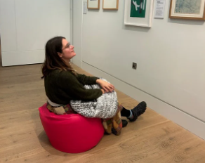
There are lots more seats outside the Gallery.  You can sit at a wooden bench or a table. | 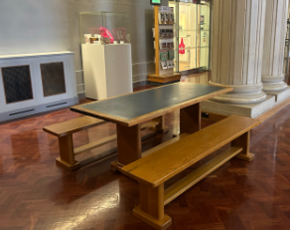
Outside the Gallery, you can eat and drink. There is also a café with more seating.  It can be more busy and noisy than the Gallery. | 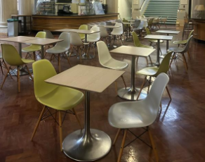

Eating and drinking
You cannot eat or drink inside the Gallery. | 
There are lots of seats outside the Gallery.  You can bring your own food and drink to eat here. | 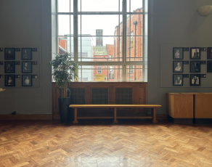
There is also a café with tables and seats, at the opposite end of the hall.  This is the Parkinson Court Café. | 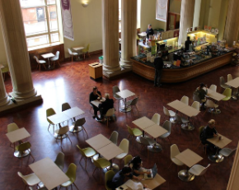
The café sells a range of sandwiches, snacks, and hot and cold drinks.  You can pay with cash or card. | 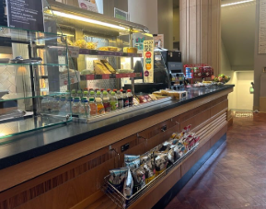
The café is open:  Monday  Tuesday  Wednesday  Thursday  Friday | 
The café is open from  8.30am to 3.00pm.  It can be busy and loud during lunch times. | 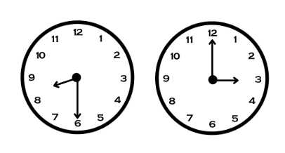

Finding the bathrooms
In the basement of Parkinson Building, there are mens’, ladies’ and gender neutral accessible toilets.  They are open for the public to use. | 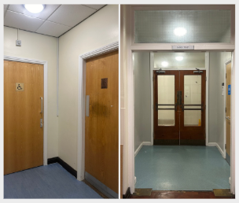
To find the toilets, exit the Gallery and turn left towards the steps. | 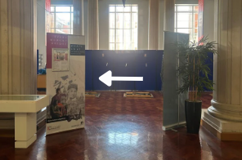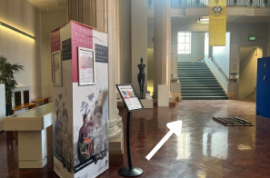
Walk down 22 steps to the basement, or use the accessible lift. | 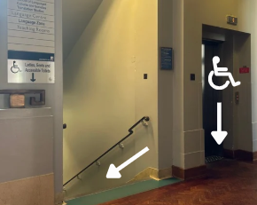
You will see a room full of computers in front of you.  For the ladies’ bathrooms, turn left, and left again. | 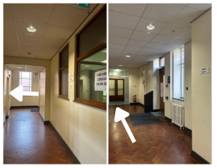
For the mens’ bathrooms, turn right, then left.  Continue down the corridor until you reach the toilets on your left. | 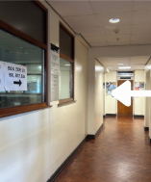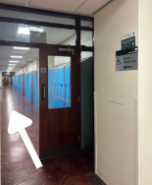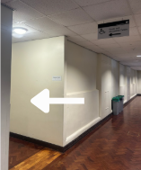
There is a wheelchair accessible, unisex toilet outside both bathrooms.  Baby changing facilities are available in the accessible toilet outside the ladies’ bathroom. | 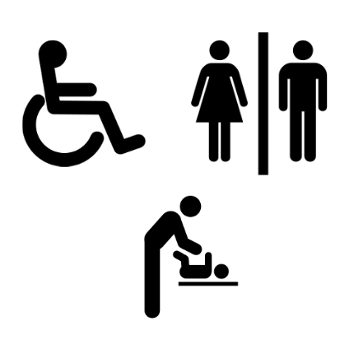

Accessible bathrooms
The nearest right-hand transfer bathroom is in the Basement.  The nearest left-hand transfer bathroom in on the Ground Floor. | 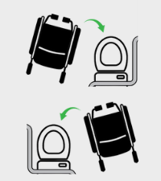
To find the bathroom, see the map on Page 10.  Look for this yellow symbol.  Some also have baby-changing facilities. | 
All accessible bathrooms have step-free access via lift.  You do not need a RADAR key. | 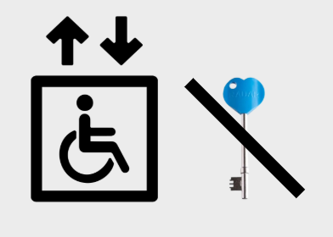

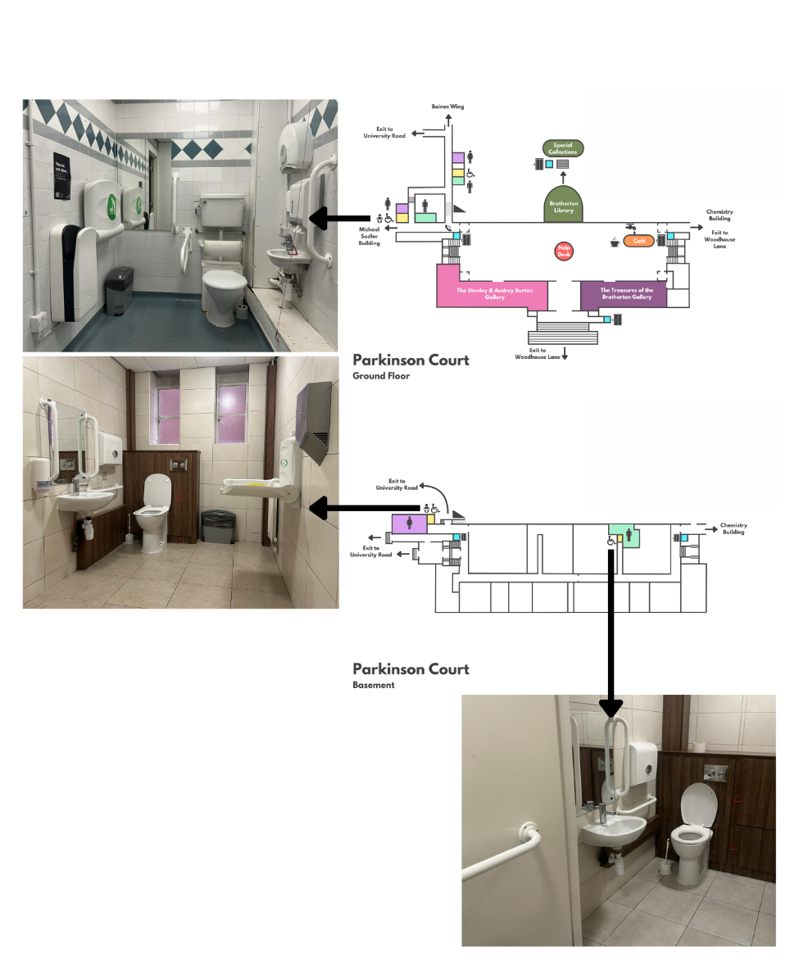
Find a copy of this map on Page 10.
We can provide further details of the dimensions and facilities.

If you hear the fire alarm
In the unlikely event of a fire, a loud continuous alarm will sound.  If you hear this alarm, you should immediately evacuate the building by the nearest exit. | 
All staff are trained to assist in case of an emergency.  Please follow staff instructions and leave the Gallery. Ask for help if you need. | 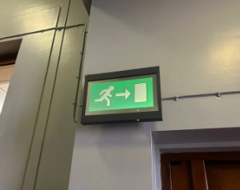
Follow the green signs to exit the building.  Wait on the grass opposite the Parkinson Steps until it is safe to return inside. | 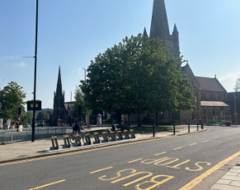

Shop
There is a small shop in the Gallery.  You can buy souvenirs, like books, postcards, greeting cards, pencils or tote bags. | 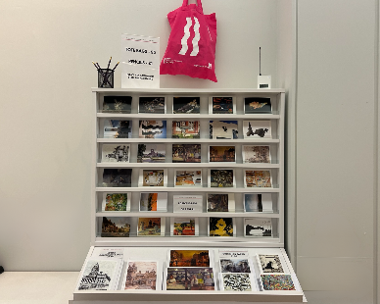
The shop is cashless. You can only pay by card or contactless. | 
You don’t have to buy anything.  You can also buy most items after your visit, on the online shop. | 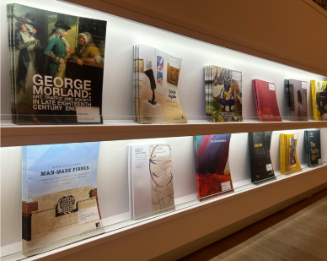

Leaving the Gallery
When you leave the Gallery, a member of staff will thank you.  You can exit the building the same way you entered. | 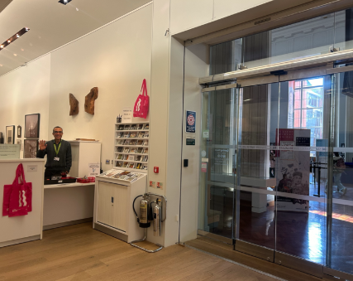
You can take leaflets from the desk. They tell you about exhibitions and events.  You can sign up to the mailing list. You will receive regular emails. | 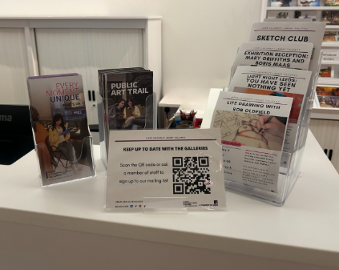
Before you go, you can ask any questions about finding your way to our other Gallery, around the University, or the local area.  If you enjoyed your visit, or had any problems, you can share any feedback with them. | 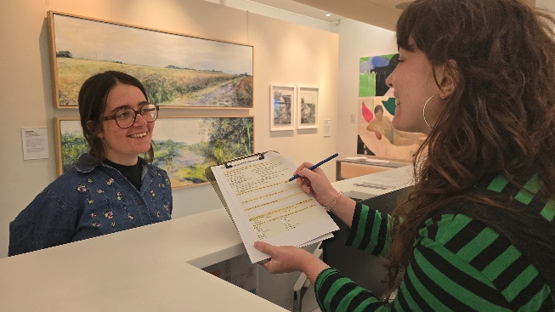

Contact us
Please talk to us if you have queries or need any help in advance of your visit.
We can answer calls and emails Tuesday to Saturday, 10.00am to 5.00pm.
On the day of your visit, our Visitor Services Team will be available to help.
Website: library.leeds.ac.uk/Galleries
Phone: 0113 343 2778 | 
Email: gallery@leeds.ac.uk | 
Social media: @LULGalleries | 

