

Sarah Roberts: SICK (a note from 40 Sandilands Road and other stories)
Large Print Exhibition Guide

Introduction
‘SICK (a note from 40 Sandilands Road and other stories)’ presents a new commission by Leeds-based artist Sarah Roberts (b.1980, Eryri, Wales) exploring environments of care. This new body of work investigates the permeation that occurs between domestic and hospital settings when it comes to providing palliative and chronic care. It also highlights the inherent strangeness of these lived spaces that become acutely hybrid and constructed.
Being Roberts’ first institutional solo show, ‘SICK’ draws on the artist’s memories and experiences while growing up. It takes the standpoint of a young carer or what Roberts terms ‘a sick-adjacent person’, reflecting on the everyday situations lived by a sick person and their family where care is coupled with moments of escapism and a longing for normality. The exhibition is structured in a series of staged areas, where boundaries are blurred and objects appear in unexpected places, addressing notions of instability, chance, veiling and voyeurism.
‘SICK’ also draws on the research Roberts conducted during a six-month residency at the University of Leeds in 2024. Roberts studied a wide range of materials around healthcare from our Cultural Collections. These included items relating to hospitals, medical objects, cookery recipes for convalescents, folk remedies, hygiene, human anatomy, illness and restorative practices.
A selection of these items is currently on display in our Treasures of the Brotherton Library across Parkinson Building. In addition, Roberts also connected and exchanged knowledge and ideas with key university researchers from disciplines such as Philosophy and Medical Humanities. She also drew inspiration from the artefacts and archives held in the University’s Museum of the History of Science, Technology and Medicine and the Thackray Museum of Medicine, Leeds.
Roberts has worked across a wide range of media including ceramics, industrial materials, found objects, medical paraphernalia, collage, sound, scent and, for the first time, woven textiles and blown glass. The resulting artwork is an aesthetically rich and multi-layered immersive installation that, whilst dealing with challenging issues, aims to be joyful and cathartic.

A Guide to help you navigate the space is available in the gallery and an accompanying zine edition by Sarah Roberts featuring collaged images and creative writing is on sale in our shop.
The exhibition is accompanied by a supporting programme of events. These will include a series of sound art workshops led by artist Alex de Little aimed at students with caring experiences in collaboration with the University’s Plus Programme.

Please do not touch the artworks on display.

Guide

THE SANCTUARY
Inspired from water cooler moments in hospital corridors and a distillation of therapeutic spa cures noted in the archives from the University of Leeds’ Cultural Collections. These are coupled with ideas of seaside rest cures and the artist’s own teenage escapes to normalcy via an arcade down the beach.

THE HOARD
Leftovers and pushed out pieces of normal household baggage, the materials of missed opportunities.

THE SICK ROOM
Re¬flections on the artist’s childhood memories of permeation of the domestic space with medical paraphernalia, coupled with prescribed methodologies for creating the ideal sick room from books from the University of Leeds’ Cultural Collections

THE TEENAGE BEDROOM
The memory of a room of a sick-adjacent teenager, sculpted into parts and reconfigured to wrap around The Sick Room

DOLPHIN FRIEZE (AROUND THE WALL)
A recollection of the joyous act of drawing dolphins on bedroom walls: decoration and order amid chaos here remade in ceramic, a process which currently brings joy to the artist.

NOTES FROM 40 SANDILANDS ROAD
Collection of collaged and mixed-media drawings, 2025.

SOUND
A euphoric glitching mix of 90’s songs that offered an escape or apparent normalcy to the artist in a long-term sick environment.

SCENT
The exhibition is punctuated by two complementary scents. One is a blend of molecules evoking the mix of Lavender water and disinfectant, selected for its tonic properties according to material found in the University of Leeds’ Cultural Collections. The other scent is a blend of molecules that reflect remembered moments and bodies.

FURTHER SUPPORT LABEL
If you are affected by any of the themes in this exhibition and feel you need further support, you can find a list of resources and organisations by scanning the QR code below.

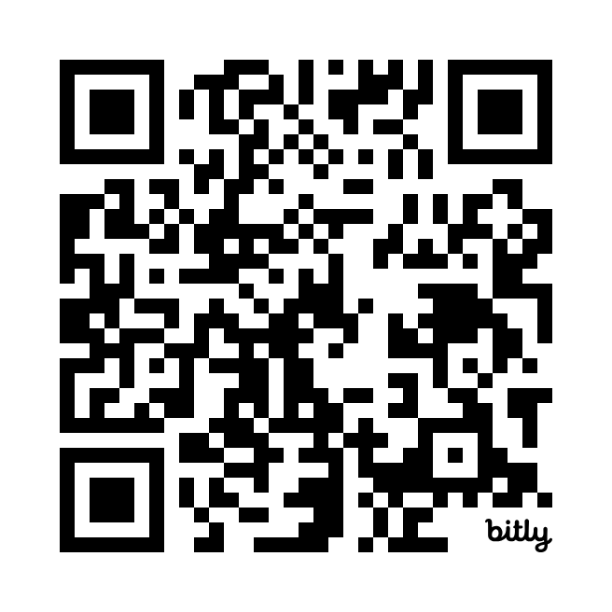
https://bit.ly/SickResources

